# Type Casting in C

Typecasting allows us to convert one data type into other. In C language, we use cast operator for typecasting which is denoted by (type).

Syntax:

1. (type)value;

#### Note: It is always recommended to convert the lower value to higher for avoiding data loss.

Without Type Casting:

1. int f= 9/4;
2. printf("f : %d\n", f );//Output: 2

With Type Casting:

1. float f=(float) 9/4;
2. printf("f : %f\n", f );//Output: 2.250000

## Type Casting example

Let's see a simple example to cast int value into the float.

1. #include<stdio.h>
2. int main(){
3. float f= (float)9/4;
4. printf("f : %f\n", f );
5. return 0;
6. }

Output:

f : 2.250000

# Bitwise Operator in C

The bitwise operators are the operators used to perform the operations on the data at the bit-level. When we perform the bitwise operations, then it is also known as bit-level programming. It consists of two digits, either 0 or 1. It is mainly used in numerical computations to make the calculations faster.

We have different types of bitwise operators in the C programming language. The following is the list of the bitwise operators:

|  |  |
| --- | --- |
| Operator | Meaning of operator |
| & | Bitwise AND operator |
| | | Bitwise OR operator |
| ^ | Bitwise exclusive OR operator |
| ~ | One's complement operator (unary operator) |
| << | Left shift operator |
| >> | Right shift operator |

Let's look at the truth table of the bitwise operators.

|  |  |  |  |  |
| --- | --- | --- | --- | --- |
| X | Y | X&Y | X|Y | X^Y |
| 0 | 0 | 0 | 0 | 0 |
| 0 | 1 | 0 | 1 | 1 |
| 1 | 0 | 0 | 1 | 1 |
| 1 | 1 | 1 | 1 | 1 |

### Bitwise AND operator

Bitwise AND operator is denoted by the single ampersand sign (&). Two integer operands are written on both sides of the (&) operator. If the corresponding bits of both the operands are 1, then the output of the bitwise AND operation is 1; otherwise, the output would be 0.

For example,

1. We have two variables a and b.
2. a =6;
3. b=4;
4. The binary representation of the above two variables are given below:
5. a = 0110
6. b = 0100
7. When we apply the bitwise AND operation in the above two variables, i.e., a&b, the output would be:
8. Result = 0100

As we can observe from the above result that bits of both the variables are compared one by one. If the bit of both the variables is 1 then the output would be 1, otherwise 0.

Let's understand the bitwise AND operator through the program.

1. #include <stdio.h>
2. int main()
3. {
4. int a=6, b=14;  // variable declarations
5. printf("The output of the Bitwise AND operator a&b is %d",a&b);
6. return 0;
7. }

In the above code, we have created two variables, i.e., 'a' and 'b'. The values of 'a' and 'b' are 6 and 14 respectively. The binary value of 'a' and 'b' are 0110 and 1110, respectively. When we apply the AND operator between these two variables,

a AND b = 0110 && 1110 = 0110

Output

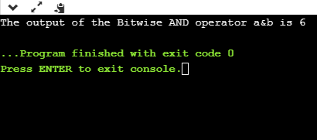

### Bitwise OR operator

The bitwise OR operator is represented by a single vertical sign (|). Two integer operands are written on both sides of the (|) symbol. If the bit value of any of the operand is 1, then the output would be 1, otherwise 0.

For example,

1. We consider two variables,
2. a = 23;
3. b = 10;
4. The binary representation of the above two variables would be:
5. a = 0001 0111
6. b = 0000 1010
7. When we apply the bitwise OR operator in the above two variables, i.e., a|b , then the output would be:
8. Result = 0001 1111

As we can observe from the above result that the bits of both the operands are compared one by one; if the value of either bit is 1, then the output would be 1 otherwise 0.

Let's understand the bitwise OR operator through a program.

1. #include <stdio.h>
2. int main()
3. {
4. int a=23,b=10;  // variable declarations
5. printf("The output of the Bitwise OR operator a|b is %d",a|b);
6. return 0;
7. }

Output

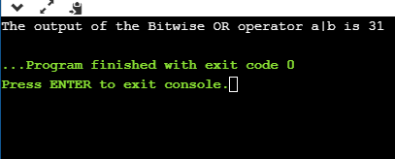

### Bitwise exclusive OR operator

Bitwise exclusive OR operator is denoted by (^) symbol. Two operands are written on both sides of the exclusive OR operator. If the corresponding bit of any of the operand is 1 then the output would be 1, otherwise 0.

For example,

1. We consider two variables a and b,
2. a = 12;
3. b = 10;
4. The binary representation of the above two variables would be:
5. a = 0000 1100
6. b = 0000 1010
7. When we apply the bitwise exclusive OR operator in the above two variables (a^b), then the result would be:
8. Result = 0000 1110

As we can observe from the above result that the bits of both the operands are compared one by one; if the corresponding bit value of any of the operand is 1, then the output would be 1 otherwise 0.

Let's understand the bitwise exclusive OR operator through a program.

1. #include <stdio.h>
2. int main()
3. {
4. int a=12,b=10;  // variable declarations
5. printf("The output of the Bitwise exclusive OR operator a^b is %d",a^b);
6. return 0;
7. }

Output

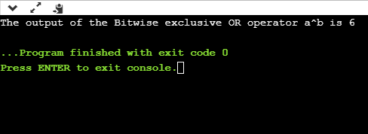

### Bitwise complement operator

The bitwise complement operator is also known as one's complement operator. It is represented by the symbol tilde (~). It takes only one operand or variable and performs complement operation on an operand. When we apply the complement operation on any bits, then 0 becomes 1 and 1 becomes 0.

For example,

1. If we have a variable named 'a',
2. a = 8;
3. The binary representation of the above variable is given below:
4. a = 1000
5. When we apply the bitwise complement operator to the operand, then the output would be:
6. Result = 0111

As we can observe from the above result that if the bit is 1, then it gets changed to 0 else 1.

Let's understand the complement operator through a program.

1. #include <stdio.h>
2. int main()
3. {
4. int a=8;  // variable declarations
5. printf("The output of the Bitwise complement operator ~a is %d",~a);
6. return 0;
7. }

Output

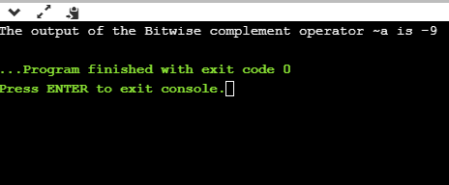

### Bitwise shift operators

Two types of bitwise shift operators exist in C programming. The bitwise shift operators will shift the bits either on the left-side or right-side. Therefore, we can say that the bitwise shift operator is divided into two categories:

* Left-shift operator
* Right-shift operator

Left-shift operator

It is an operator that shifts the number of bits to the left-side.

Syntax of the left-shift operator is given below:

1. Operand << n

Where,

Operand is an integer expression on which we apply the left-shift operation.

n is the number of bits to be shifted.

In the case of Left-shift operator, 'n' bits will be shifted on the left-side. The 'n' bits on the left side will be popped out, and 'n' bits on the right-side are filled with 0.

For example,

1. Suppose we have a statement:
2. int a = 5;
3. The binary representation of 'a' is given below:
4. a = 0101
5. If we want to left-shift the above representation by 2, then the statement would be:
6. a << 2;
7. 0101<<2 = 00010100

Let's understand through a program.

1. #include <stdio.h>
2. int main()
3. {
4. int a=5; // variable initialization
5. printf("The value of a<<2 is : %d ", a<<2);
6. return 0;
7. }

Output

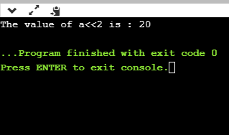

Right-shift operator

It is an operator that shifts the number of bits to the right side.

Syntax of the right-shift operator is given below:

1. Operand >> n;

Where,

Operand is an integer expression on which we apply the right-shift operation.

N is the number of bits to be shifted.

In the case of the right-shift operator, 'n' bits will be shifted on the right-side. The 'n' bits on the right-side will be popped out, and 'n' bits on the left-side are filled with 0.

For example,

1. Suppose we have a statement,
2. int a = 7;
3. The binary representation of the above variable would be:
4. a = 0111
5. If we want to right-shift the above representation by 2, then the statement would be:
6. a>>2;
7. 0000 0111 >> 2 = 0000 0001

Let's understand through a program.

1. #include <stdio.h>
2. int main()
3. {
4. int a=7; // variable initialization
5. printf("The value of a>>2 is : %d ", a>>2);
6. return 0;
7. }

Output

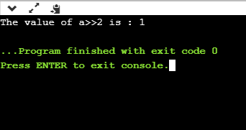

# What is the 2s complement in C?

The 2s complement in C is generated from the 1s complement in C. As we know that the 1s complement of a binary number is created by transforming bit 1 to 0 and 0 to 1; the 2s complement of a binary number is generated by adding one to the 1s complement of a binary number.

In short, we can say that the 2s complement in C is defined as the sum of the one's complement in C and one.

In the above figure, the binary number is equal to 00010100, and its one's complement is calculated by transforming the bit 1 to 0 and 0 to 1 vice versa. Therefore, one's complement becomes 11101011. After calculating one's complement, we calculate the two's complement by adding 1 to the one's complement, and its result is 11101100.

Let's create a program of 2s complement.

1. #include <stdio.h>
2. int main()
3. {
4. int n;  // variable declaration
5. printf("Enter the number of bits do you want to enter :");
6. scanf("%d",&n);
7. char binary[n+1];  // binary array declaration;
8. char onescomplement[n+1]; // onescomplement array declaration
9. char twoscomplement[n+1]; // twoscomplement array declaration
10. int carry=1; // variable initialization
11. printf("\nEnter the binary number : ");
12. scanf("%s", binary);
13. printf("%s", binary);
14. printf("\nThe ones complement of the binary number is :");
16. // Finding onescomplement in C
17. for(int i=0;i<n;i++)
18. {
19. if(binary[i]=='0')
20. onescomplement[i]='1';
21. else if(binary[i]=='1')
22. onescomplement[i]='0';
23. }
24. onescomplement[n]='\0';
25. printf("%s",onescomplement);

28. printf("\nThe twos complement of a binary number is : ");
30. // Finding twoscomplement in C
31. for(int i=n-1; i>=0; i--)
32. {
33. if(onescomplement[i] == '1' && carry == 1)
34. {
35. twoscomplement[i] = '0';
36. }
37. else if(onescomplement[i] == '0' && carry == 1)
38. {
39. twoscomplement[i] = '1';
40. carry = 0;
41. }
42. else
43. {
44. twoscomplement[i] = onescomplement[i];
45. }
46. }
47. twoscomplement[n]='\0';
48. printf("%s",twoscomplement);
49. return 0;
50. }

Output

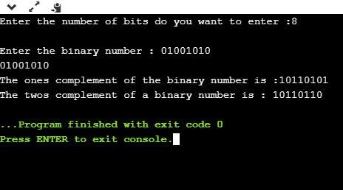

### Analysis of the above program,

* First, we input the number of bits, and it gets stored in the 'n' variable.
* After entering the number of bits, we declare character array, i.e., char binary[n+1], which holds the binary number. The 'n' is the number of bits which we entered in the previous step; it basically defines the size of the array.
* We declare two more arrays, i.e., onescomplement[n+1], and twoscomplement[n+1]. The onescomplement[n+1] array holds the ones complement of a binary number while the twoscomplement[n+1] array holds the two's complement of a binary number.
* Initialize the carry variable and assign 1 value to this variable.
* After declarations, we input the binary number.
* Now, we simply calculate the one's complement of a binary number. To do this, we create a loop that iterates throughout the binary array, for(int i=0;i<n;i++). In for loop, the condition is checked whether the bit is 1 or 0. If the bit is 1 then onescomplement[i]=0 else onescomplement[i]=1. In this way, one's complement of a binary number is generated.
* After calculating one's complement, we generate the 2s complement of a binary number. To do this, we create a loop that iterates from the last element to the starting element. In for loop, we have three conditions:
  + If the bit of onescomplement[i] is 1 and the value of carry is 1 then we put 0 in twocomplement[i].
  + If the bit of onescomplement[i] is 0 and the value of carry is 1 then we put 1 in twoscomplement[i] and 0 in carry.
  + If the above two conditions are false, then onescomplement[i] is equal to twoscomplement[i].